**Checklist: Adding/Modifying Lesson**

1. In r4beginners project, create_post()
   1. Example: create_post(“lesson1-syntax”)
   2. Probably easiest to copy template from existing lessons
   3. Can add a featured.png for the preview image
   4. Make sure to knit .Rmd before building website
   5. Make sure to push the changes
2. Once the lesson is finalized, copy the .Rmd file and paste it into the r4beginners-lessons project (list is linked to the github repository where people can download the lesson plans)
   1. Change YML so just title and output

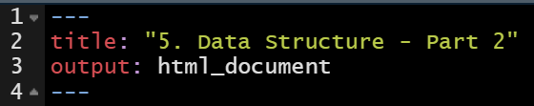

* 1. Remove emo at “the end”
  2. If there are any images, move to “images” folder in r4beginners lessons
  3. Make sure to push the changes

1. Pull changes on Posit Cloud
   1. Log in via GitHub – this will take me to project I can edit, and click pull to update from GitHub
2. The R4Beginners RStudio Project is linked to the r4beginners-lessons github repo, so it should update the .Rmd files automatically, but would be good to check on RStudio